|  |
| --- |
| [Type the company name] |
| Installing SQL Server 2008R2 |
| Windows Server 2008 Standard – 32bit |

|  |
| --- |
|  |

# Installing Microsoft SQL Server 2008 R2 Express

* 1. Double Click on “**SQLEXPR_x64_ENU.exe”.**

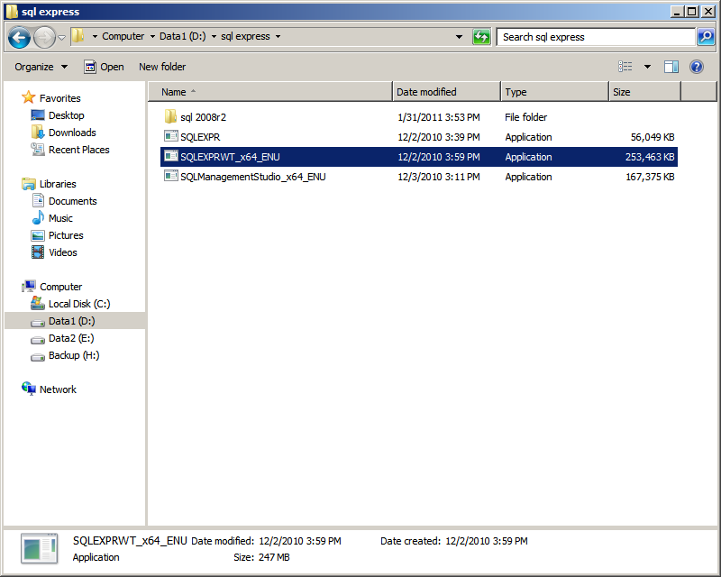

Figure 1: SQLEXPRWT_x64_ENU

* 1. If Windows Installer 4.5 or higher is not installed the below message will be displayed

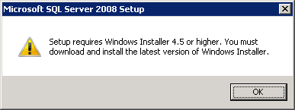

To install Windows Installer 4.5 use the following link to download.

<http://www.microsoft.com/download/en/details.aspx?displaylang=en&id=8483>

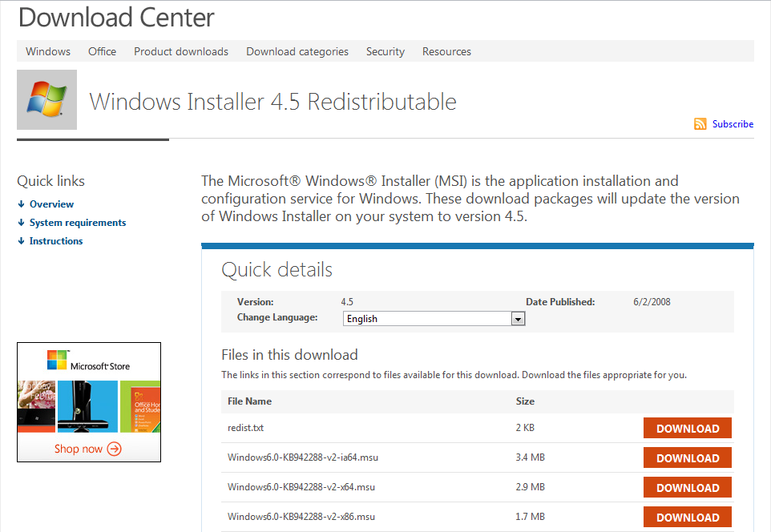

* 1. Click “**OK**”

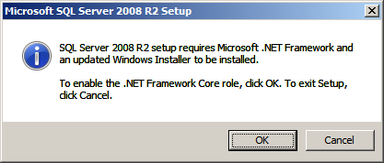

Figure 2 : SQL Server Confirmation

* 1. Click on “**Installation**”

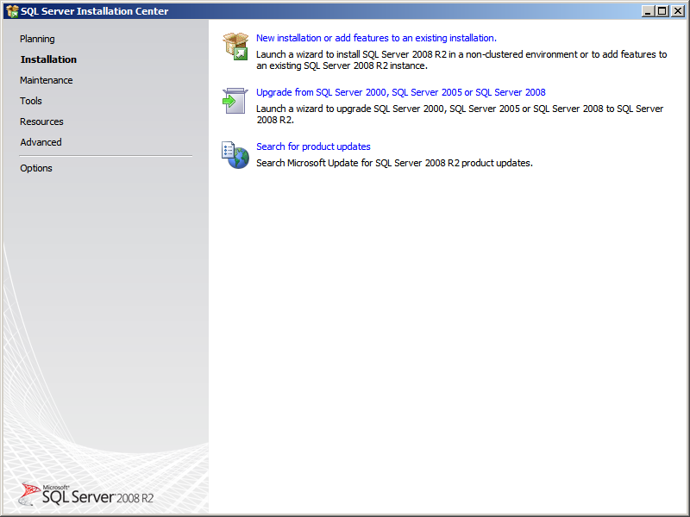

Figure 3 : SQL Server Installation Center

* 1. Click “**New Installation or add features to an existing installation**”

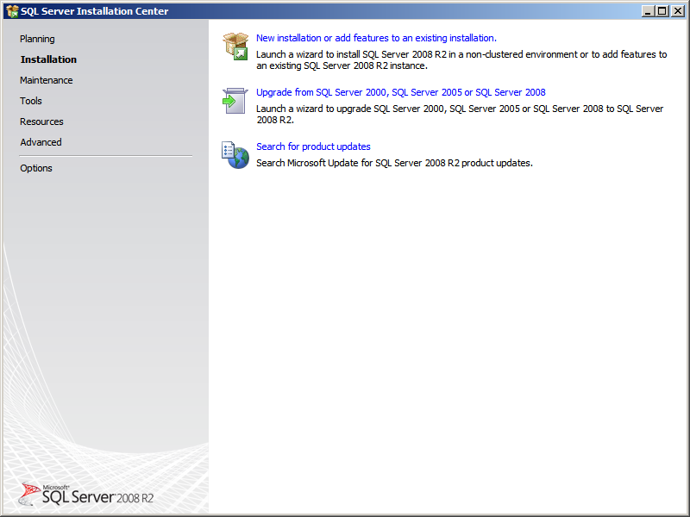

Figure 4 : SQL Server Installation Center

* 1. Please Wait dialog comes

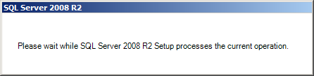

Figure 5 : Please wait window

* 1. Select “**I accept the license terms**”
  2. Click “**Next**”

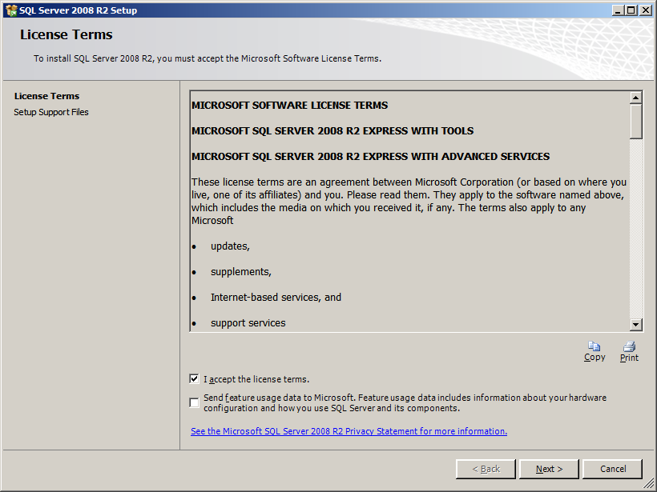

Figure 6 : License Terms

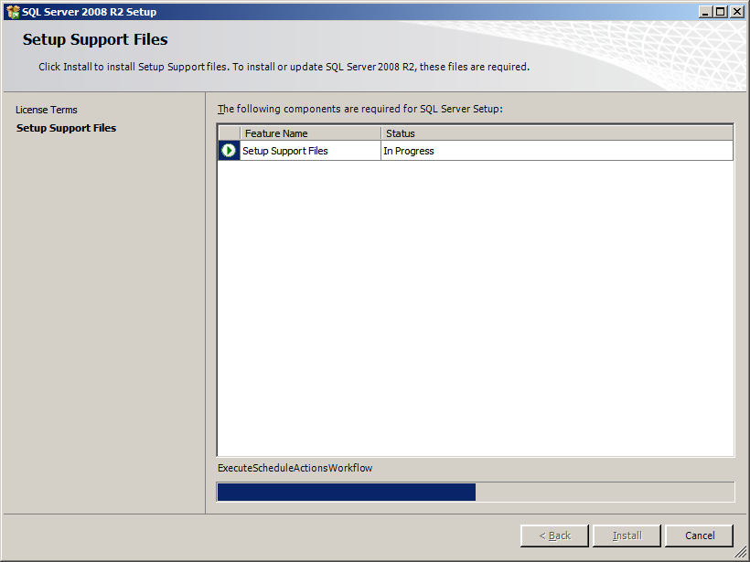

Figure 7 : Setup Support Files

* 1. Select “**Database Engine Services**” check box
  2. Click “**Next>**” button

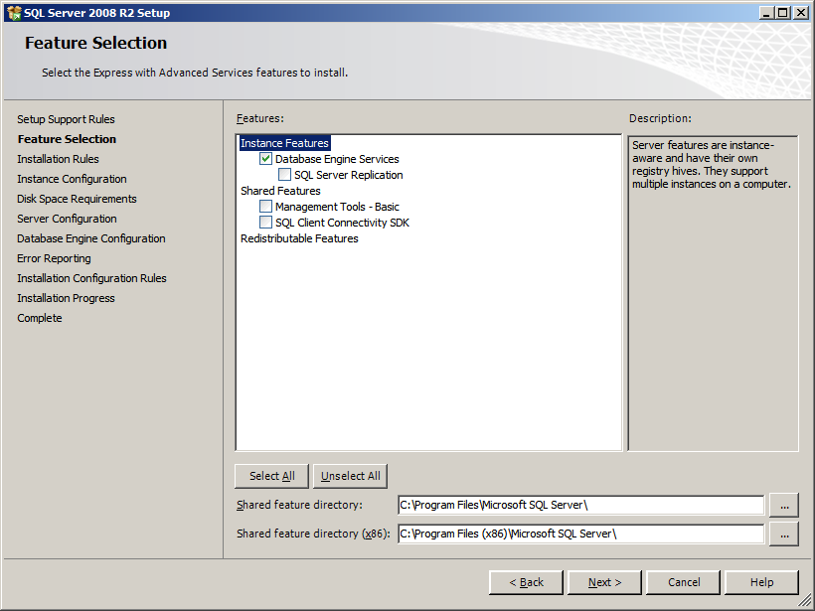

Figure 8 : Feature selection

* 1. Select **“Named Instance”** radio button
  2. Click “**Next>**”

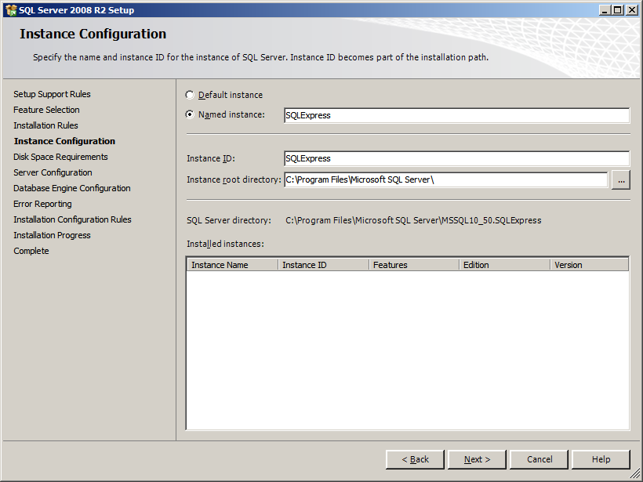

Figure 9: Instance Configuration

* 1. Select “**Account Name**” as “**NT AUTHORITY\SYSTEM**” from the dropdown list
  2. Select “**Startup Type**” as “**Automatic**” from the dropdown list for SQL Server Database Engine and SQL Server Browser services.
  3. Click “**Next** **>**”

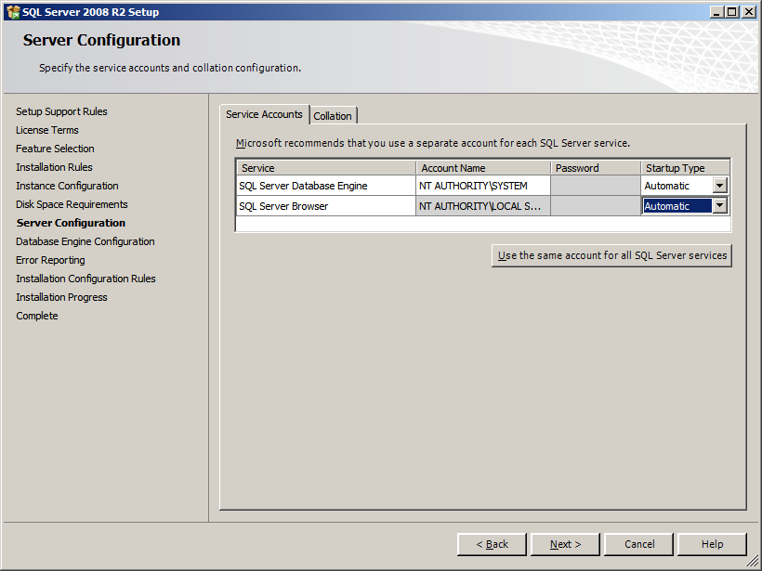

Figure 10 : Server Configuration

* 1. Select “**Mixed Mode (SQL Server authentication and Windows authentication)**”
  2. Enter Password in “**Enter password**” text field
  3. Enter Same Password in “**Confirm password**” text field
  4. Click on “**Next >**”

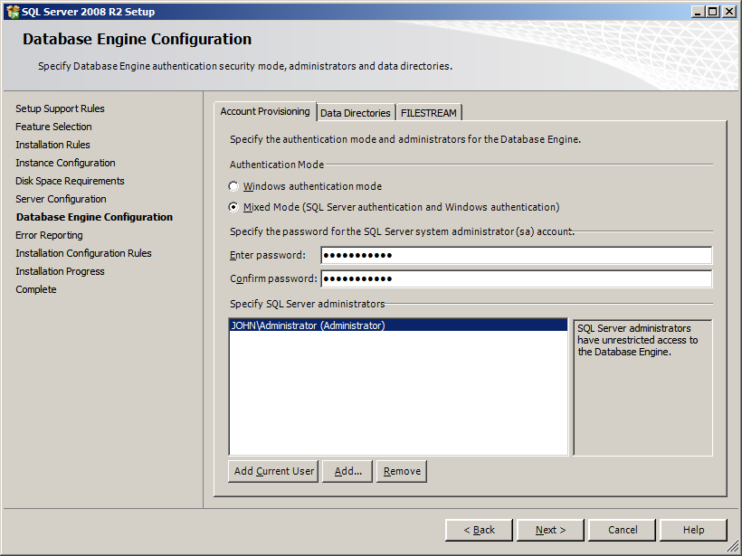

Figure 11 : Database Engine Configuration

* 1. Click “**Next >**”

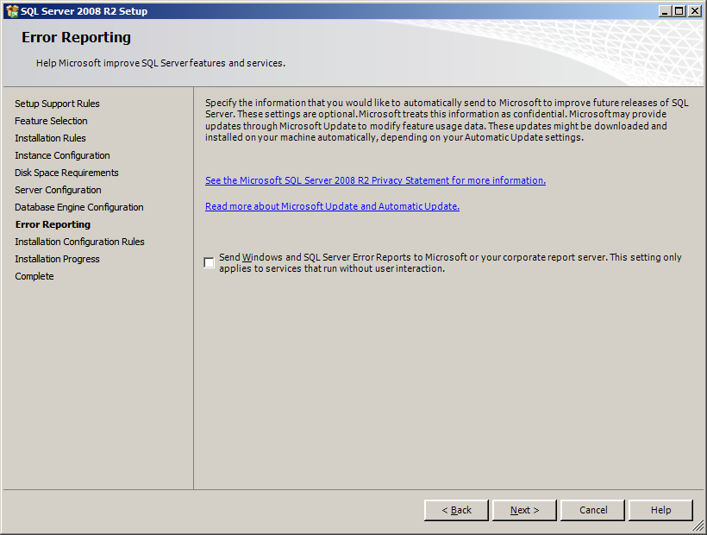

Figure 12 : Error Reporting

* 1. Click “**Close**”

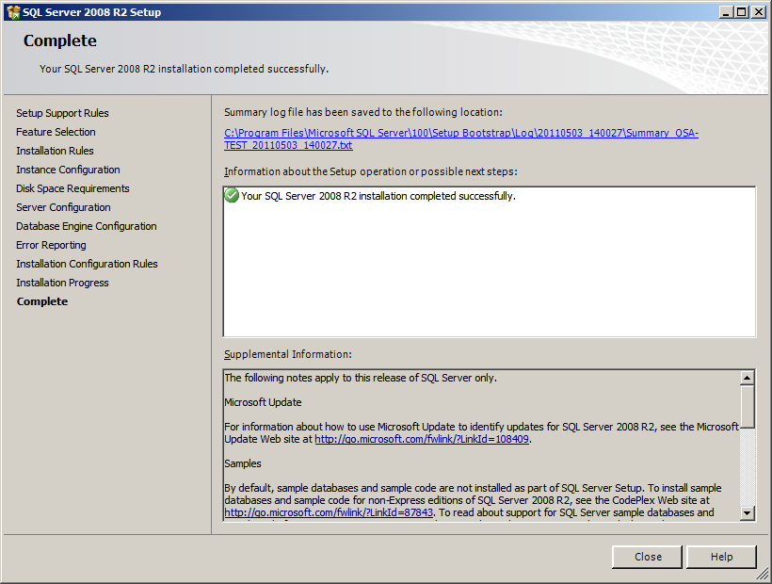

Figure 13 : Complete window